**DAILY ONLINE ACTIVITIES SUMMARY**

|  |  |  |  |  |  |  |  |  |
| --- | --- | --- | --- | --- | --- | --- | --- | --- |
| **Date:** | **30-5-2020** | | | | | **Name:** | **Likhitha.M** | |
| **Sem & Sec** | **6th sem ‘A’** | | | | | **USN:** | **4al17cs046** | |
| **Online Test Summary** | | | | | | | | |
| **Subject** | | **Python Application program** | | | | | | |
| **Max. Marks** | | **30** | | **Score** | | | **14** | |
| **Certification Course Summary** | | | | | | | | |
| **Course** | **Cloud Foundations** | | | | | | | |
| **Certificate Provider** | | | **Great learning** | | **Duration** | | | **3 days** |
| **Coding Challenges** | | | | | | | | |
| **Problem Statement:** Python program to read a number and print the patternwrite a java program to Count number of trailing zeros in product of array A simple solution is simply multiply and count trailing 0s in product. This solution may cause integer overflow. A better solution is based on the fact that zeros are formed by a combination of 2 and 5. Hence the number of zeros will depend on the number of pairs of 2’s and 5’s that can be formed.  Ex.: 8 * 3 * 5 * 23 * 17 * 25 * 4 * 11  23 * 31 * 51 * 231 * 171 * 52 * 22 * 111  In this example there are 5 twos and 3 fives. Hence, we shall be able to form only 3 pairs of (2*5). Hence will be 3 Zeros in the product. | | | | | | | | |
| **Status: completed** | | | | | | | | |
| **Uploaded the report in Github** | | | | | **yes** | | | |
| **If yes Repository name** | | | | | **https://github.com/likhithaMantaral/Daily-status** | | | |
| **Uploaded the report in slack** | | | | | **yes** | | | |

Online test Details:

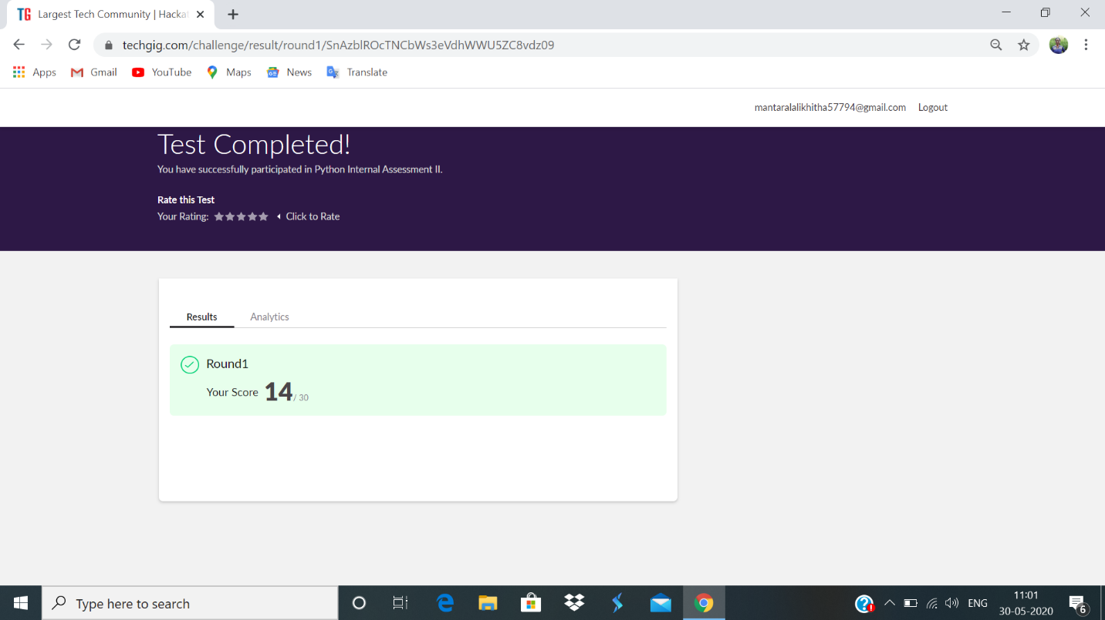

Certification Course Details:

**Service Models, Abstraction Levels, SPIDERS**

Style of computing in which massively scalable IT related capabilities are provided “ as a service” using internet technologies to multiple “external customers”. Myths of cloud computing: 1.thers’s one single ‘cloud’ 2.All u need is your credit card 3.The cloud always saves you money 4. The cloud always reduces your workload.





coding challenges:

1.2

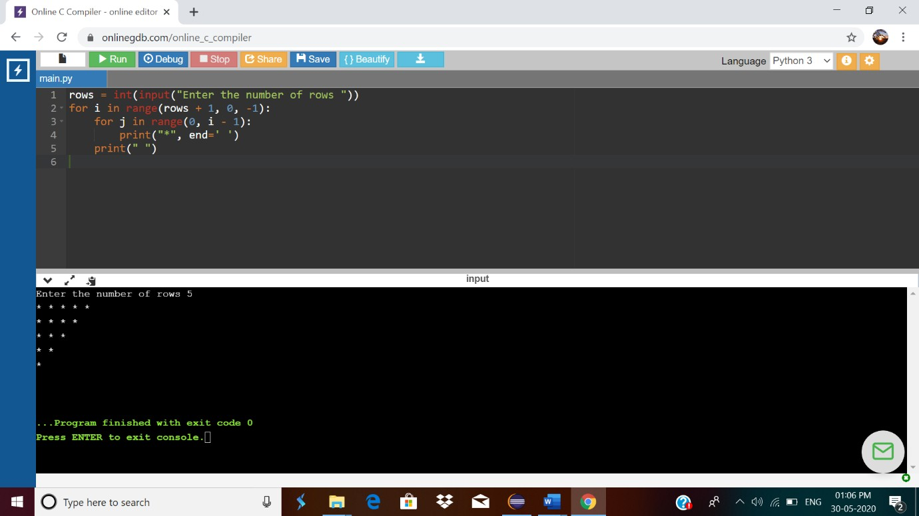

2.

